Project Proposal

CSIS 3126

2/21/19

Aramis Vazquez

**­­­­­­­­­­­­­­­­­­______________________________________________________________________________**

**Introduction**

Almost every kid, teen or even adult plays or has played some sort of video games, whether it is old or new. Most game industries make their games available to be played by everyone, despite some games being rated teen or mature. This is a smart way to increase revenue or even be the new game everyone wants to talk about or is talking about. Well, Nearest Out is just the game to grab you by the eyes and suck you in. For our game, we want you to feel like you are in the game itself. The character will be an adventurer trying to get out of the place that you are currently in. We want the player to face obstacles and enemies that will be annoying and kill or try to kill you. Our goal is to make the player not want to stop playing.

**Gameplay**

The player will play as an adventurer named Bjorn. You are on a mission to try to collect every coin without dying from monsters in the map. Bjorn will only be allowed to shoot his bow and arrow to kill the enemies. There are various monsters in the map that will be hindering him from collecting all the coins. It’s the user’s job to maneuver Bjorn to collect all the coins without dying. If the player dies he will have to restart from the beginning and find all the coins again. Once the player collects all the coins, the game will end. Be careful, there will be coins all over.

**Gameplay:**

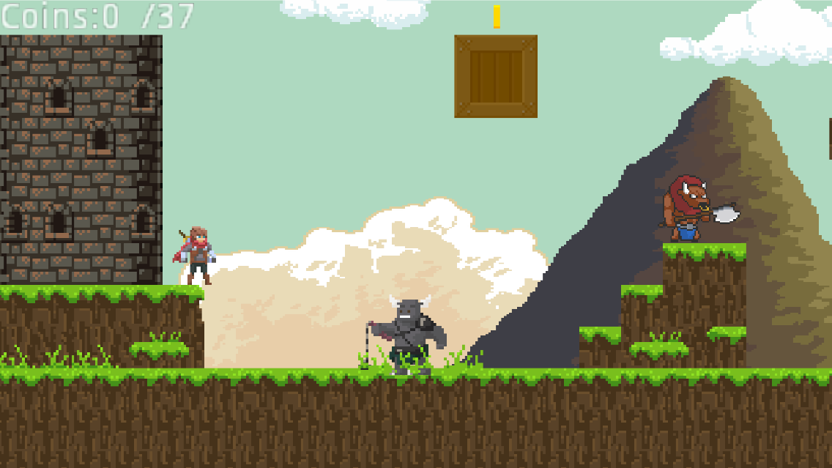

**Objectives**

**Title:** Nearest Out

**Engine:** Godot

**Scripting Language:** GD Script

**Characters:**

Bjorn (Adventurer)

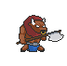Minotaur (enemy)

-There are various versions of this enemy

Grey Minotaur (enemy)

-There are various versions of this enemy

Coin (collectable)

**Basic Features:**

* Title screen will be the first thing the player sees when the game starts up
* The Title screen will have two buttons
* Player will have the ability to move both left and right and jump
* Player will have the ability to attack
* Player will collect coins
* Coins will be sporadically separated in the map
* The score of the coins collected will display
* If the enemies collide with the player, the player will die
* Player has one life
* When player dies, a game over screen will appear

Controls Keys:

* A key = move left
* D key = move right
* Space bar = jump
* F key = Shoot Bow and Arrow

**Advanced Features:**

* The first Title screen button will take you into the game
* The second Title screen button will exit the game
* The button in the Game over screen will return to the Title screen
* The camera moves with the player in every direction
* Additional animations when enemies are hit
* Additional animations when enemies are killed
* Additional animations when player dies
* Player will be allowed to double jump
* Colliding into coins will cause you to pick them up
* Game will end when all coins are collected
* Enemies will have various health
* Grey Minotaur’s speed up when hit

**Target Customers**

Nearest Out will have the availability to be played by ages 7+ due to the fact in the game you are using a sword to eliminate enemies. Although they are fantasy characters that are trying to attack you in your journey, it doesn’t seem right for a child under this age (7) to be using a bow and arrow.